**Build And Deploy To Kubernetes Cluster**

For every push to the main(can also be set to any specific branch) branch of the repository , the github workflow will trigger a job from the actions.yaml file

This will first build our docker image and push it to our docker repository.

Then this image will be used to deploy our project with manifest files as follows:

* mssql-configmap.yaml
* mssql-deployment.yaml
* mssql-pv.azure.yaml
* mssql-secret.yaml
* mvc-deployment.azure.yaml

**Step 1:**

First create secrets in your repository

* **DOCKER_REPOSITORY_PASSWORD:** This will store our docker hub’s account password. When the image is build it will be pushed in our docker hub account using this secret.
* **AZURE_CREDENTIALS:** This will be used to connect to our azure account. We will use service principal to access the azure subscription.

How to generate azure credentials

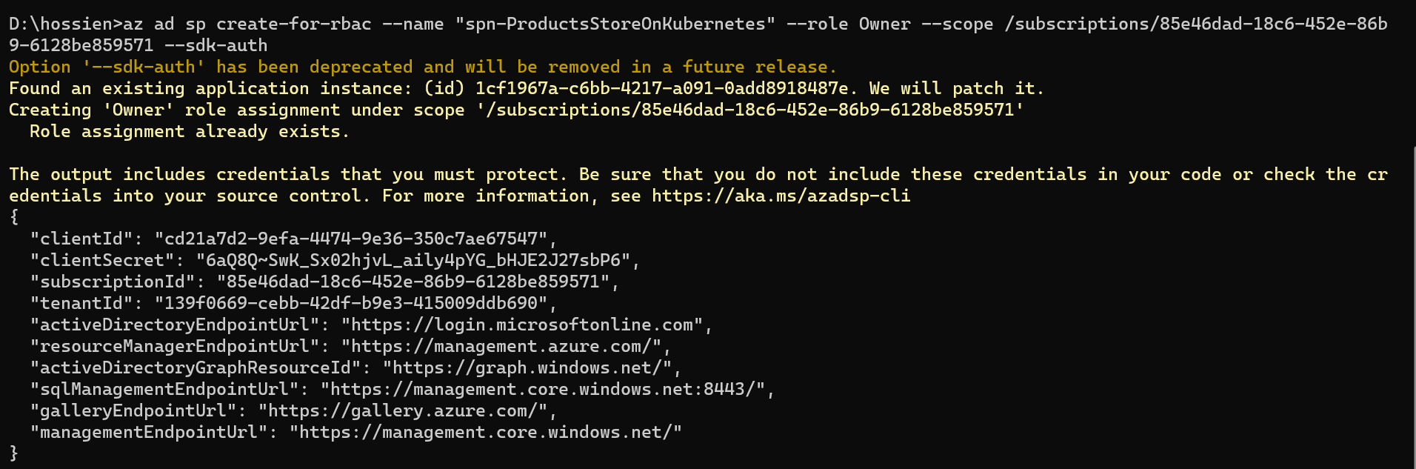

**Step 3:**

The secrets created above are used in the workflows/actions.yaml file for establishing connections.

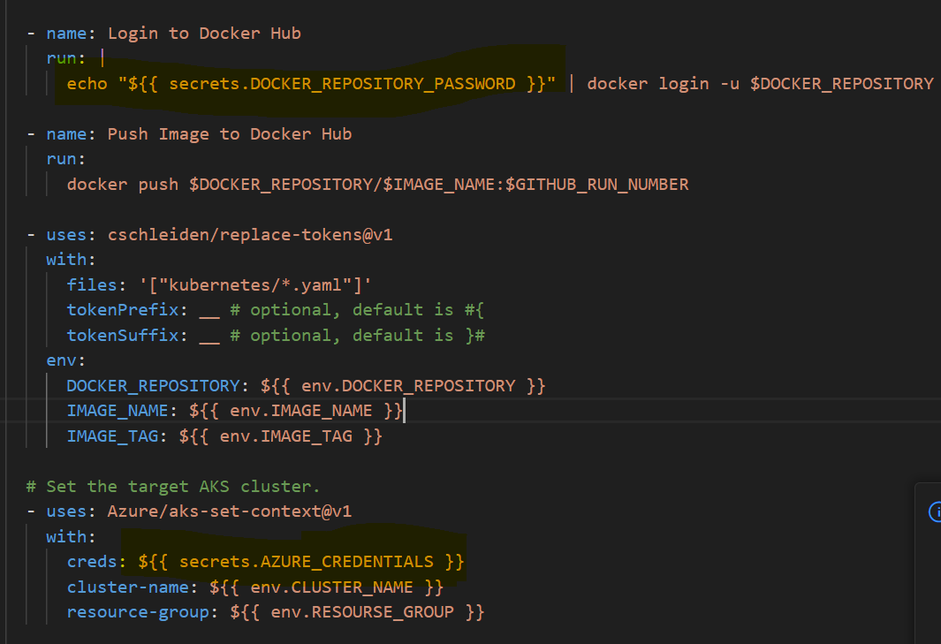

**Step 4:**

Create a Kubernetes cluster in azure with the name: aks-cluster

Under the resource group name: rg-aks-cluster

**Step 5:**

When there are any changes to our main branch, the build job gets triggered.

After the build was triggerd from. /github/workflow , an image was pushed to our repository

We can also check what have been deployed to our cluster.

